Private First Class George A. Hawn
Company B, 1st Battalion, 116th Infantry, 29th Infantry Division
Omaha Beach

Draft Registration Card
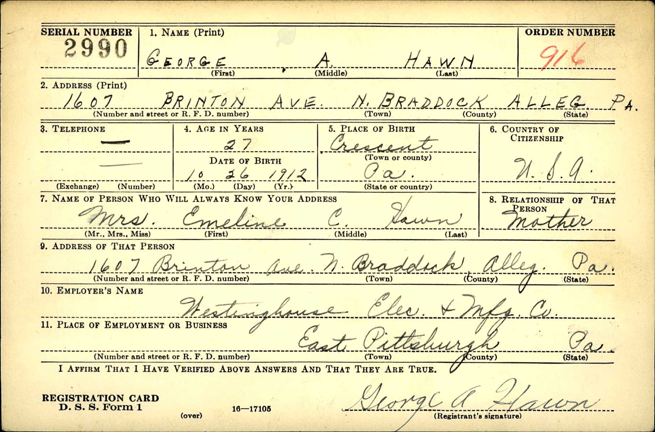

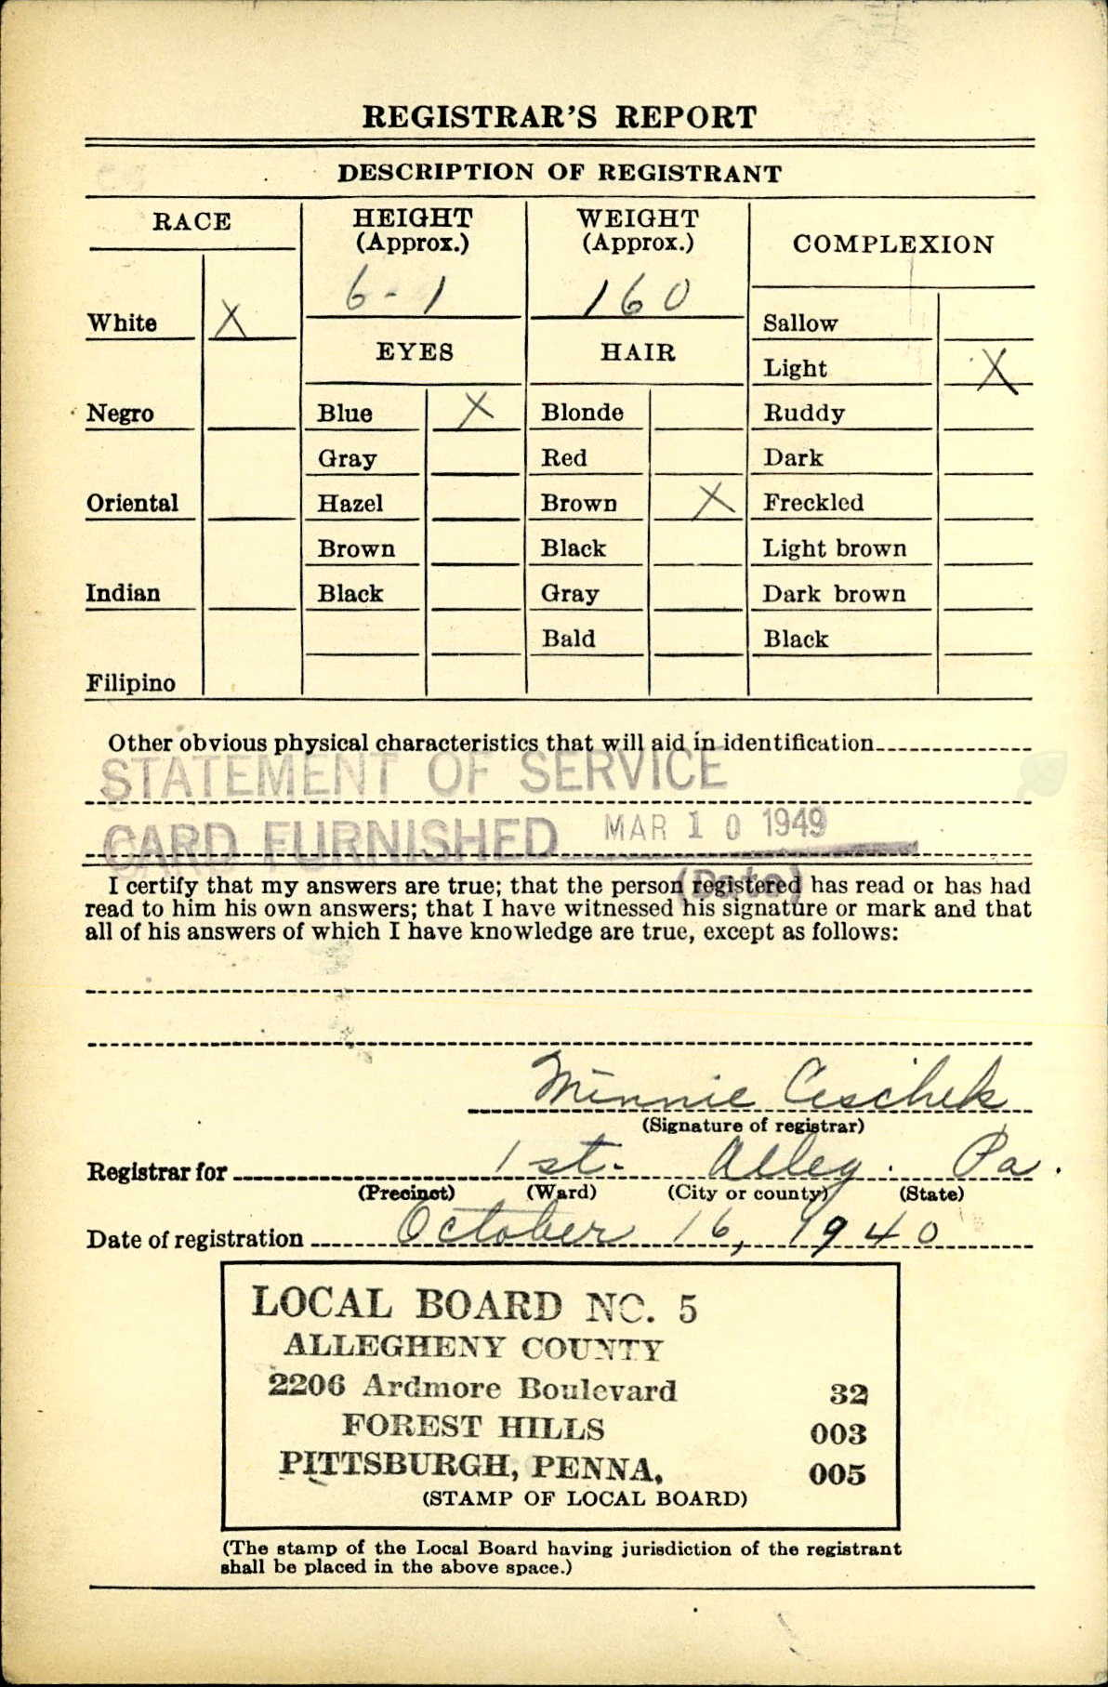
Birth Certificate
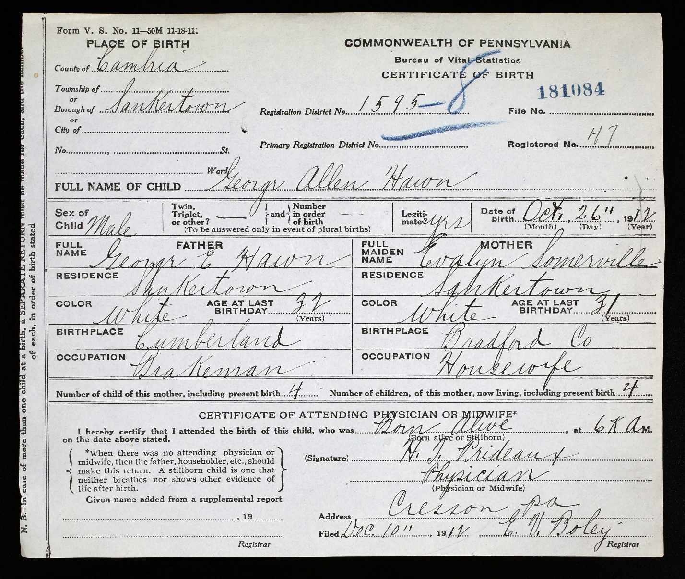

Pension Form
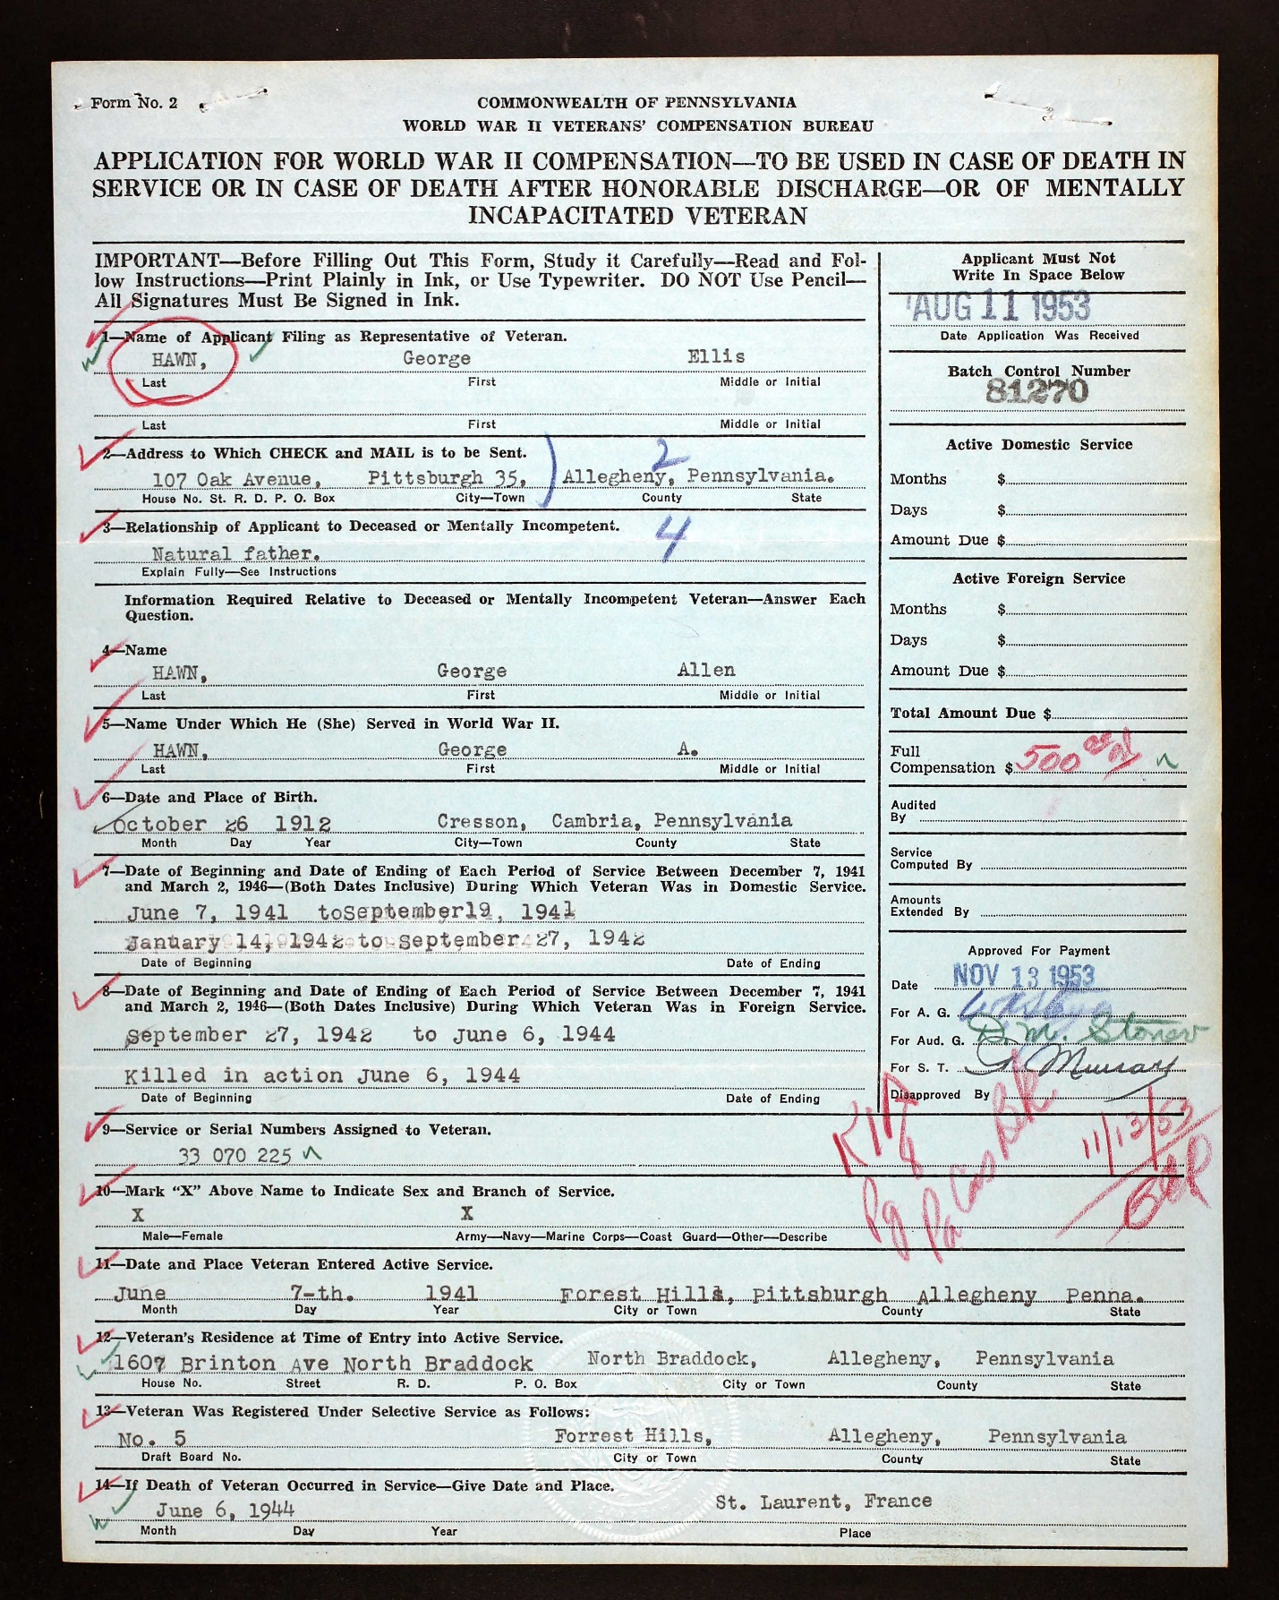

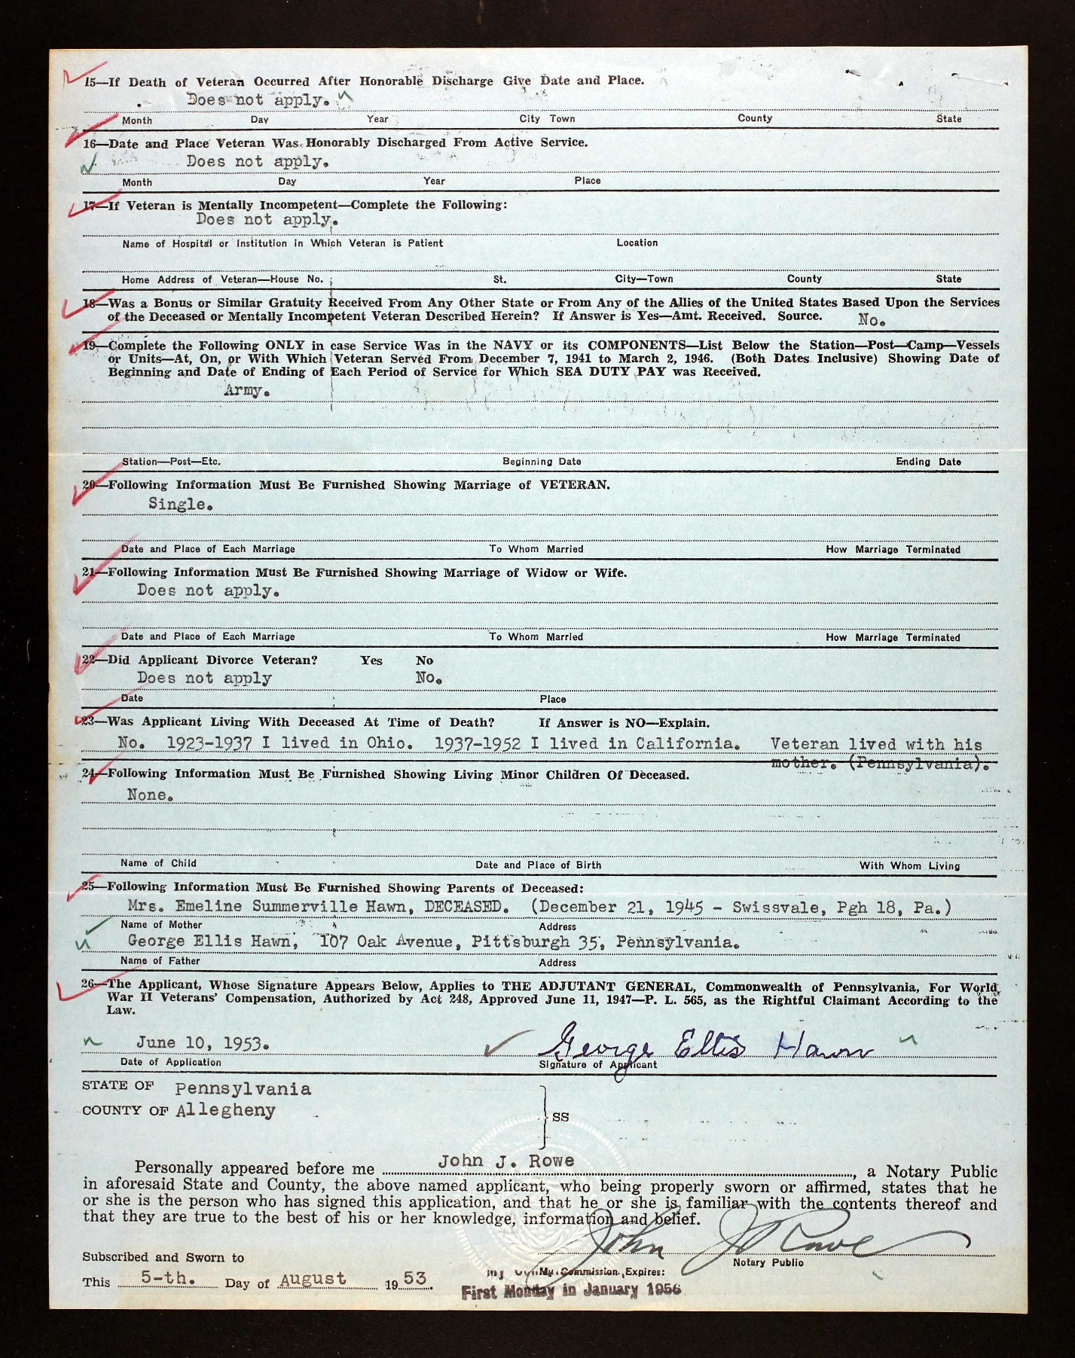

Pittsburgh Sun Telegraph, September 2, 1943
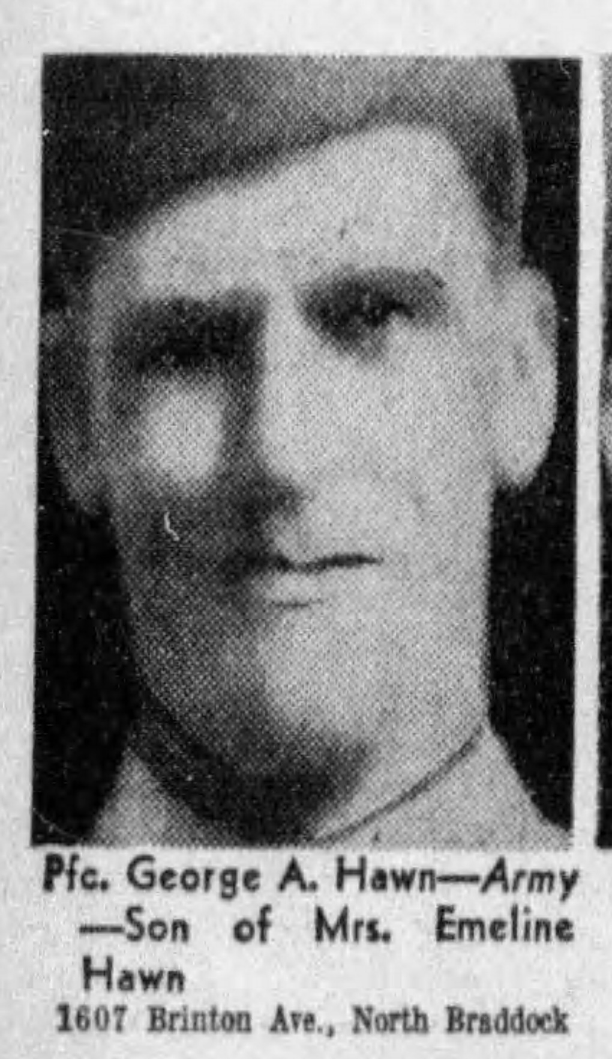

Pittsburgh Press, September 24, 1944
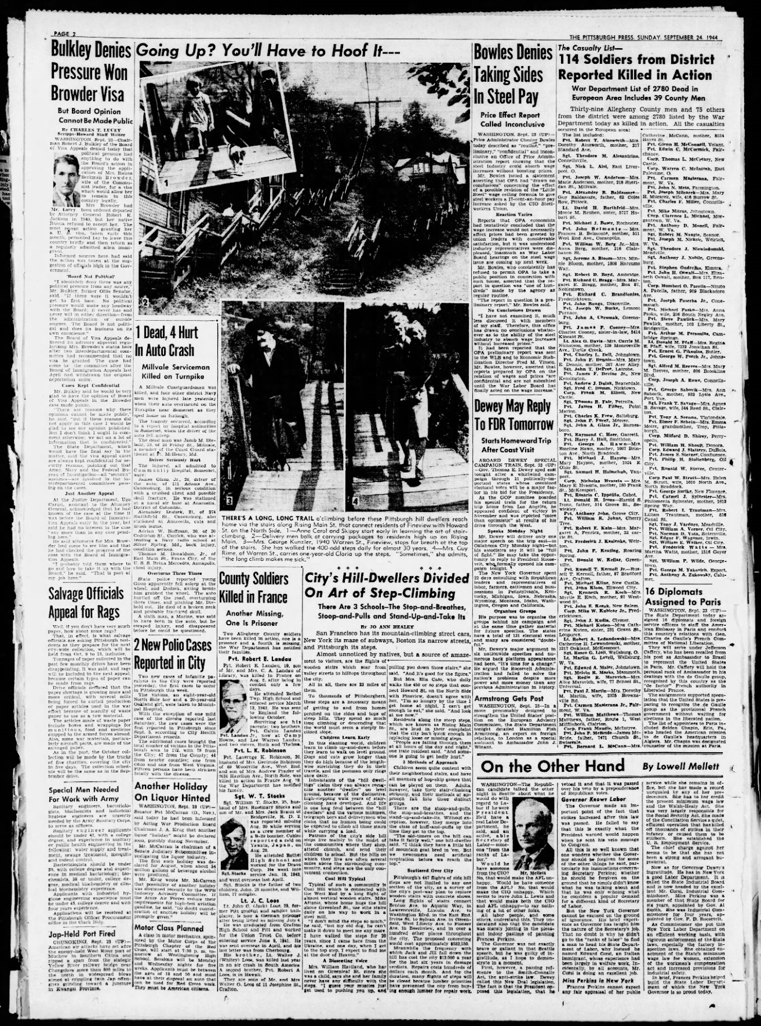
Veteran’s Burial Card
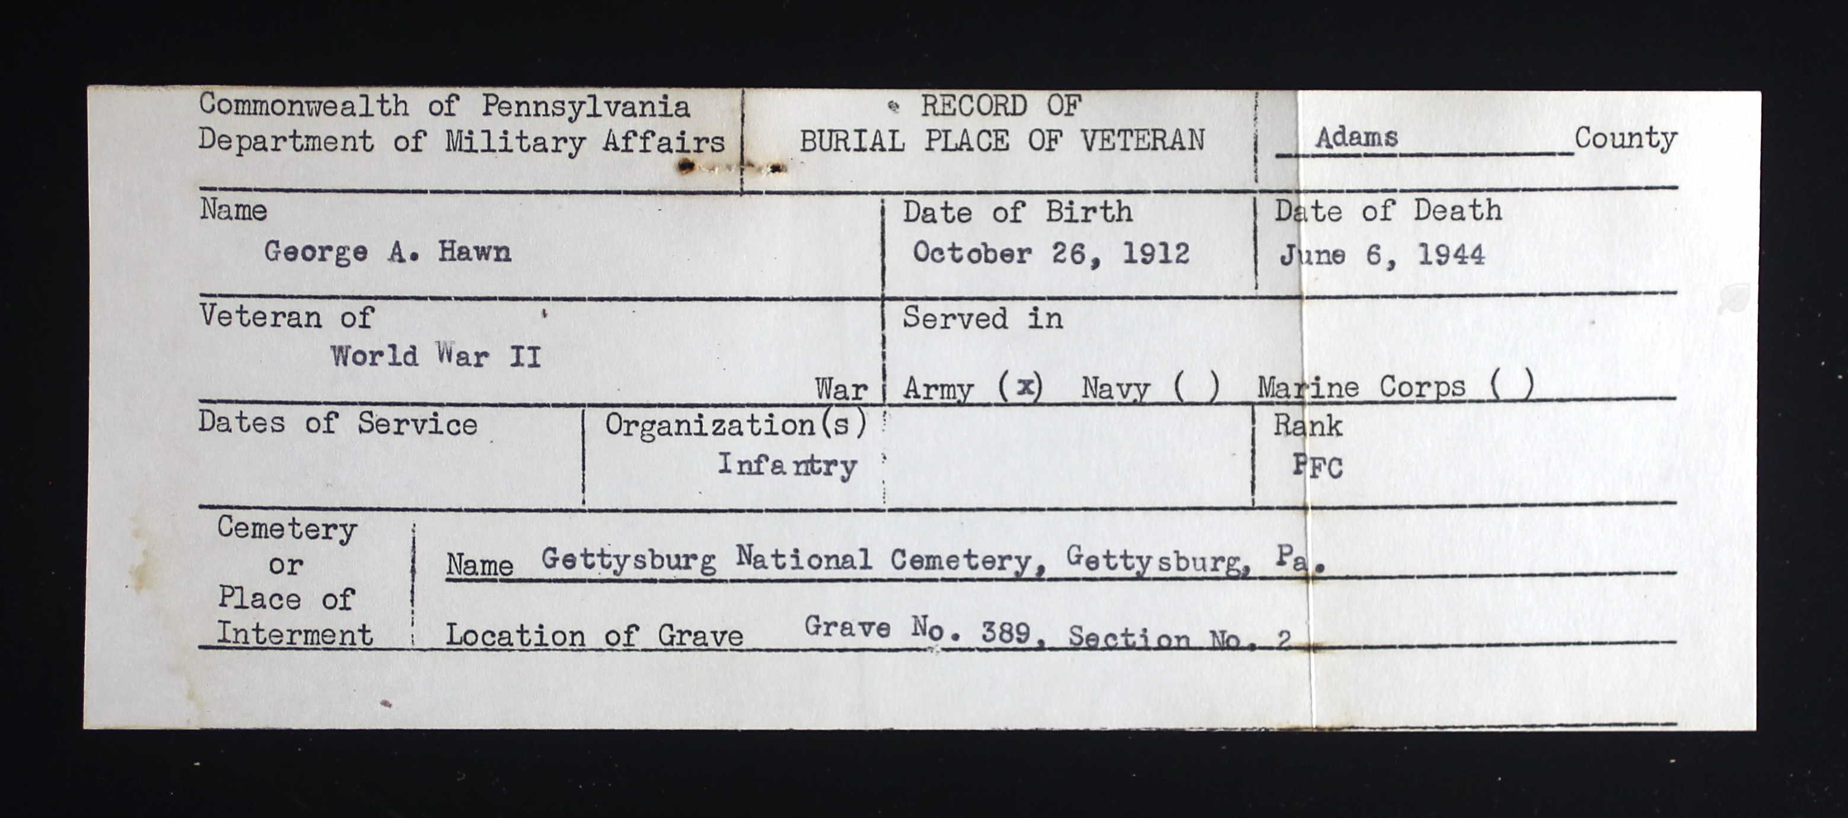

Gettysburg Compiler, April, 17, 1948
